LAB TASK 7
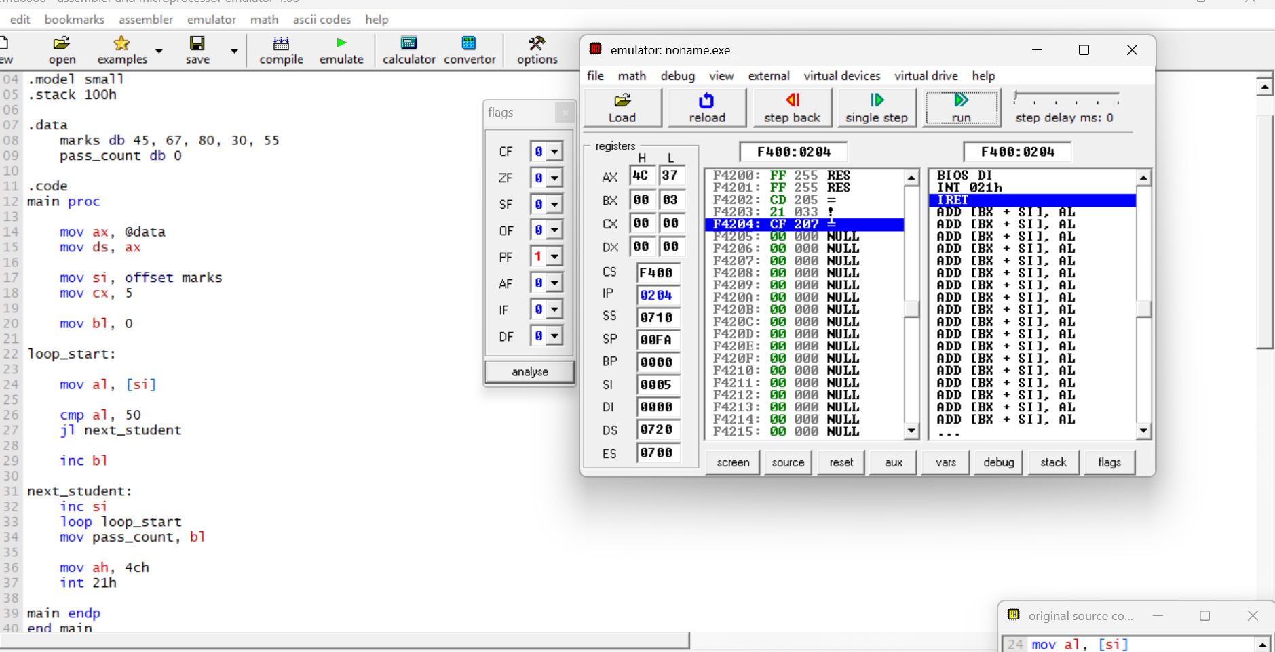
EXPLAINATION:
- mov ds, ax: initialize data segment register
- mov si, offset marks: si points to first student mark
- mov cx, 5: loop counter for 5 students
- mov bl, 0: initialize pass counter = 0
- loop_start: label for loop start
- mov al, [si]: load current student mark into al
- cmp al, 50: compare mark with 50
- jl next_student: if mark < 50 -> jump (fail)
- inc bl: increment pass count
- next_student: label for next iteration
- inc si: move to next student
- loop loop_start: repeat loop until cx = 0
- mov pass_count, bl: store final pass count
- mov ah, 4ch: prepare program exit
- int 21h: terminate program

